- Purpose
  - The purpose of this document is to describe the procedure for packaging a Crewman high speed burnisher.
- Scope
  - This SOP applies to all equipment assembly team members. The process applies to the following machine ID’s:
E083015EQM0600BE1200 – Crewman 1600 RPM Cord-Electric Burnisher
E083015EQM0607BE1200 – Crewman 1600 RPM Cord-Electric Burnisher-Canada
E083016EQM0600BE1200 – Crewman 2000 RPM Cord-Electric Burnisher
E083016EQM0600BE1200 – Crewman 2000 RPM Cord-Electric Burnisher-Canada
- Responsibilities
  - The operations manager/supervisor is responsible for enforcing this SOP.
- Materials
  - The proper materials needed for this process are listed on the machine work order.
- Definitions

- Procedure
  - Assemble a shipping box (83713). Place a “Do Not Top Load” sticker onto the corner as shown.

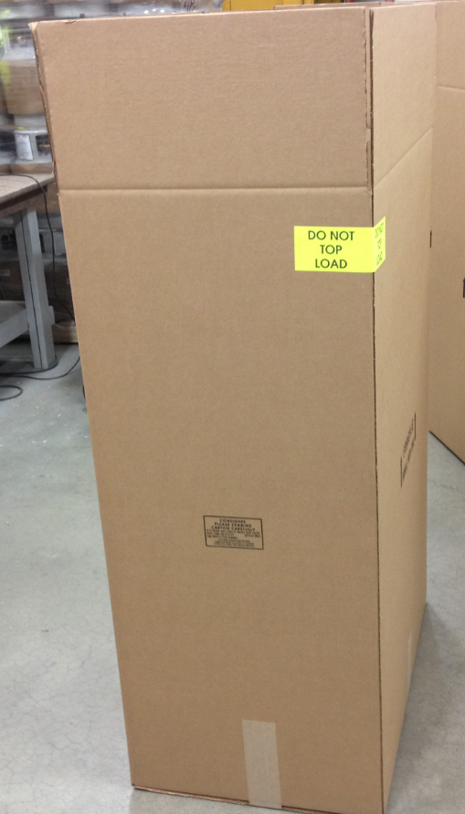

  - Place an insert (83712) into the shipping box in the orientation shown. You may need to angle the top back so that it does not fall over before the machine is in the box.

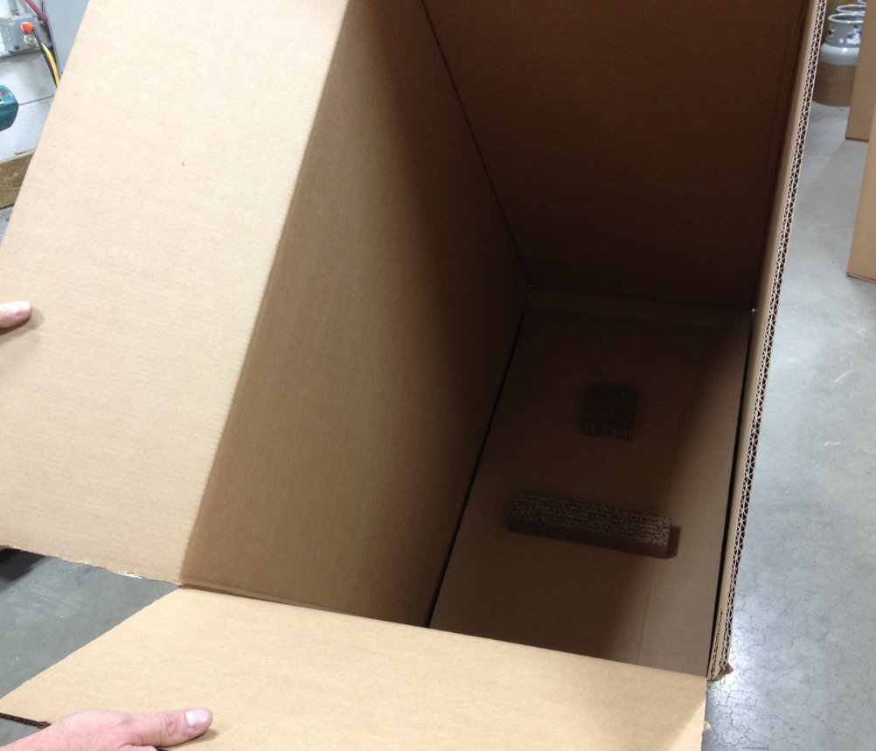

  - Lay the box onto its side.
  - Roll the machine into the box. Be sure that the insert stays in place.

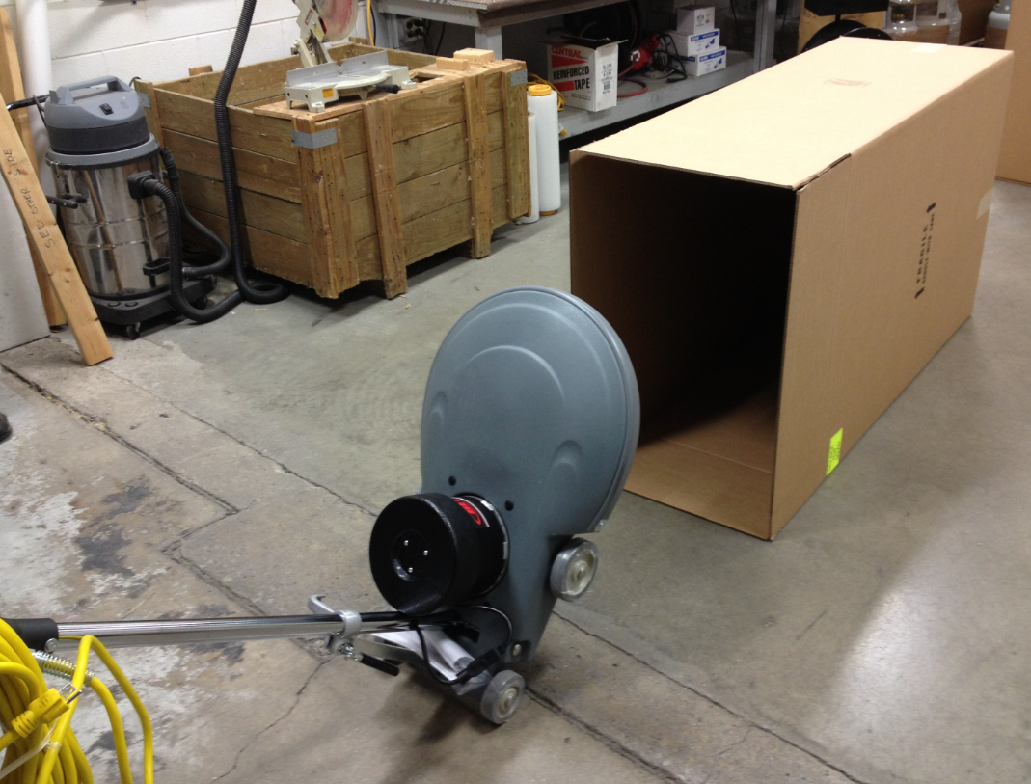

  - Stand the box up.

  - Check to make sure that the manual packet stayed with the machine.

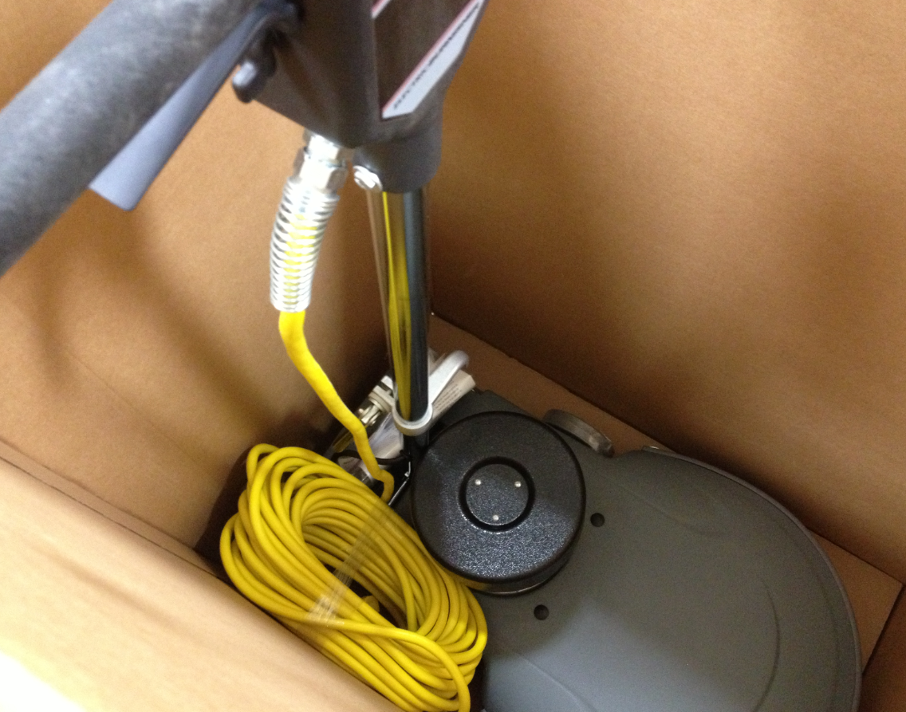

  - Place the appropriate box label onto the outside of the box as shown. The inventory ID and the serial numbers will have barcodes. Ensure the proper label goes onto the proper box.

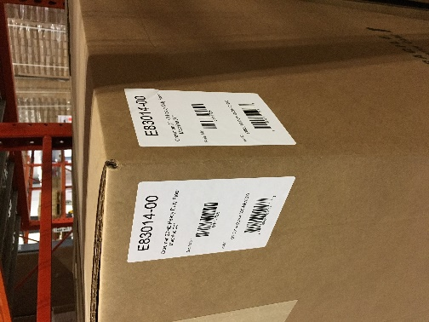

  - Tape the top of the box shut.

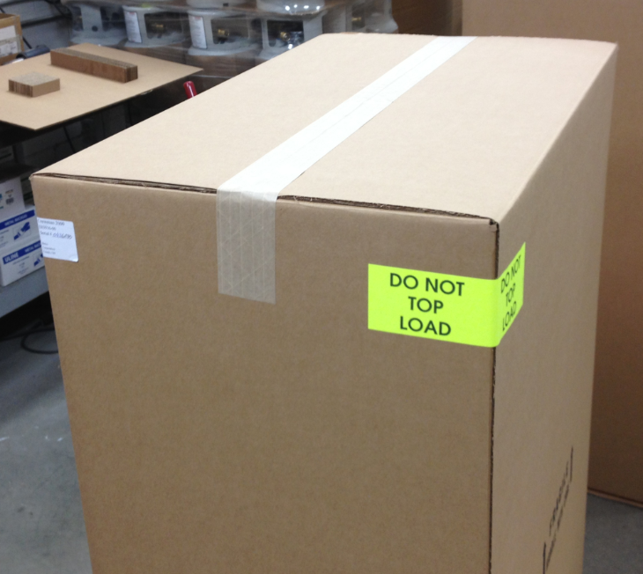

  - Put the box onto a pallet for shipment.
- References (optional section as needed)

- Training Guide

Functional Training Groups Requiring Training

- SOP Change Control

Date of Change | Reason for Change
Rev 01 - 11/22/2013 | This is the first version of the S.O.P. hence there are no revisions to this document.
Rev 02 - 1/12/2018 | Added Responsibilities section
Rev 03 - 3/14/2025 | Removed work center notes

Approvals

Submitter/Author Approval:__________________________________ Date:______________________

Management Approval:______________________________________ Date:______________________

QAU Approval:_____________________________________________ Date:______________________

